**ASSIGNMENT-1(SEMESTER 2)  
  
Write-up**

**Lecture_1**

* Fundamental root of all building block for linear algebra is VECTOR.
* There are multiple aspects in which vectors are seen, a physics student see vector differently, a CS student see it differently but a mathematics student thinks of vectors as a combination of what physics and CS student think or see.
* The physics student perspective is that vectors are arrows pointing in space. A given vector is defined by its magnitude and direction and as long as those 2 facts are true vector can be moved around.
* Vectors that live in the flat plane are two-dimensional, and those sitting in broader space that we live in are three-dimensional, the computer science perspective is that vectors are ordered lists of numbers. For ex:

$\left[\begin{matrix}5 \\ 4 \\ 1\end{matrix}\right]$

* The mathematician, on the other hand, seeks to generalise both of these views, basically saying that a vector can be anything where there's a sensible notion of adding two vectors, and multiplying a vector by a number.
* The coordinates of a vector are a pair of numbers that

basically, give instructions for how to get from the tail of that vector—at the origin—to its tip. The first number tells you how far to walk along the x-axis—positive numbers indicating rightward motion, negative numbers indicating leftward motion—and the second number tell you how far to walk parallel to the y-axis after that—positive numbers indicating upward motion, and negative numbers indicating downward motion.

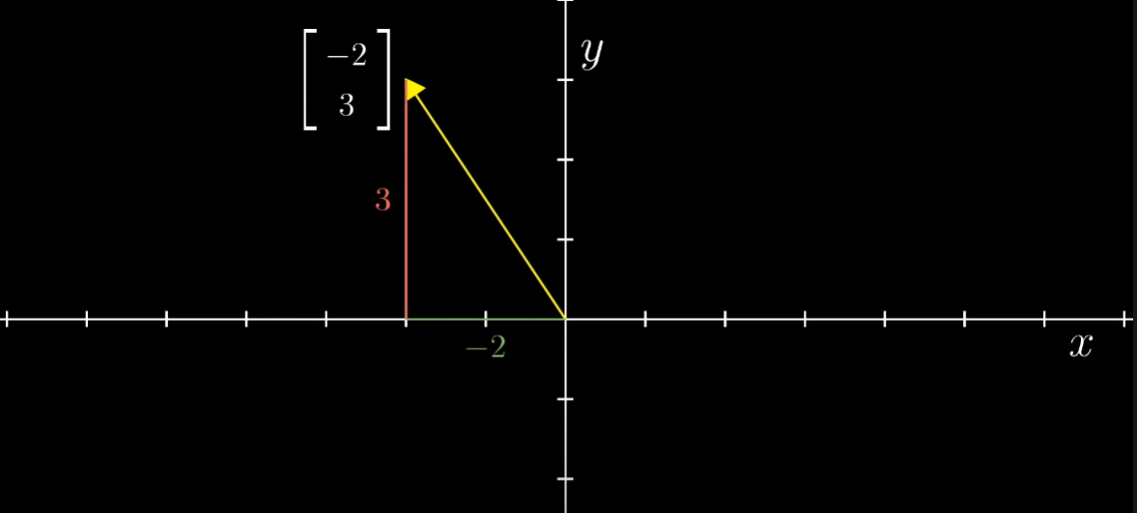

* Above is for 2-D space while for 3-D space we add a third axis called z-axis which is perpendicular to x and y axis and in this case, vector is associated with an ordered triplet of numbers where third tell us about movement in z axis.

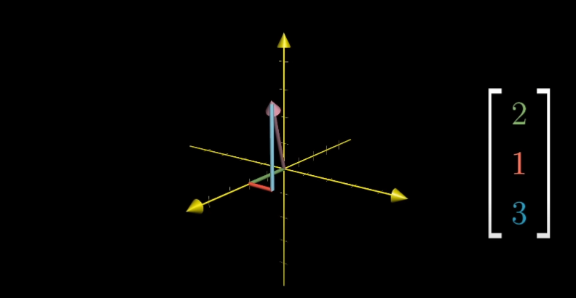

* To add two vectors, move the second one so that its tail sits at the tip of the first one; then if you draw a new vector from the tail of the first one to where the tip of the second one now sits, that new vector is their sum.

For eg.

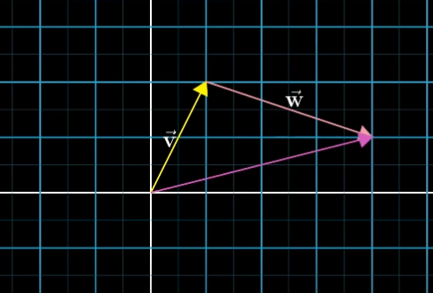

* Vectors can be formed in such a way that it looks like we are moving in coordinate system according to the mentioned coordinates and in similar way addition of vectors can be done. For example

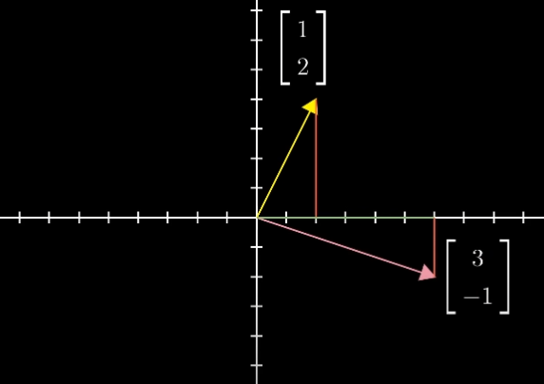

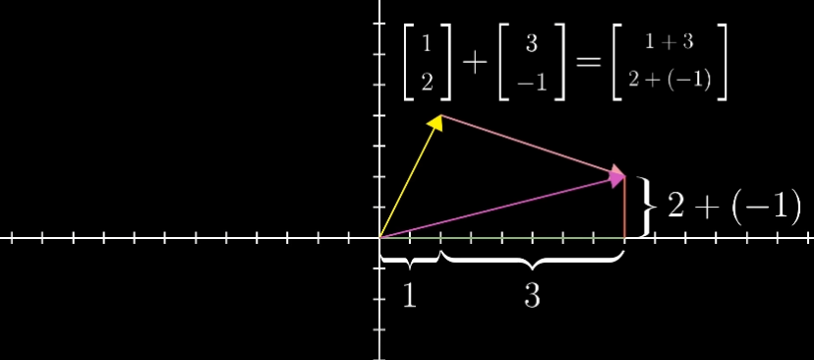

* Multiplication can be done to vector by a number. Multiplication takes place by multiplying vector by a number. Depending on the number by which a vector is multiplied it can be decided whether vector is going to be stretched or squished or whether it reverses it direction and this process is called scaling and whenever scaling of any vector takes places with a number, that number is called a scalar.

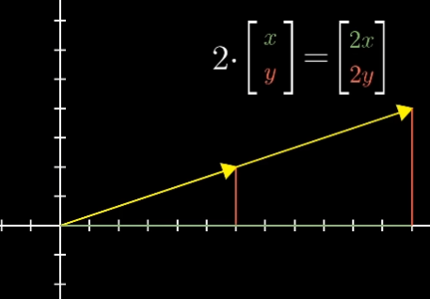

* The usefulness of linear algebra has less to do with either one of different views (of vectors) than it does with the ability to translate back and forth between them.
* It gives the data analyst a nice way to conceptualise many lists of numbers in a visual way, which can seriously clarify patterns in data, and give a global view of what certain operations do, and on the flip side, it gives people like physicists and computer graphics programmers a language to describe space and the manipulation of space using numbers that can be crunched and run through a computer.

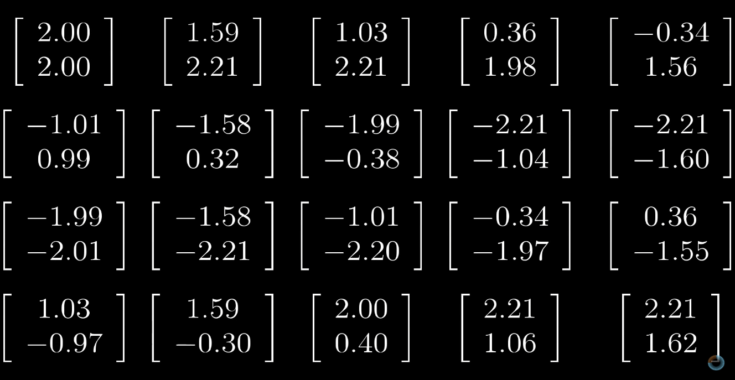

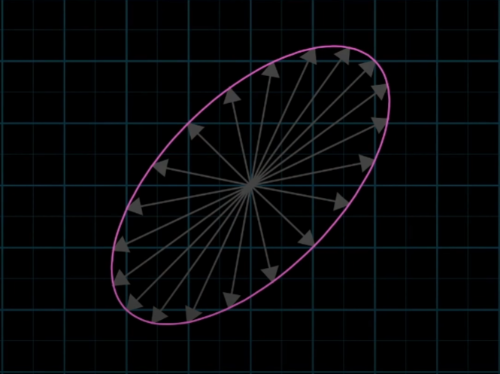

**LECTURE_2**

* In the x-y coordinate system there are two special vectors, the one pointing towards right is called i-hat (it is a unit vector) and the other pointing upwards is called j-hat (it is also a unit vector).
* **i** and **j** are the basis vectors of the x-y coordinate system.
* Scaling two vectors and adding them is called linear combination of those vectors.

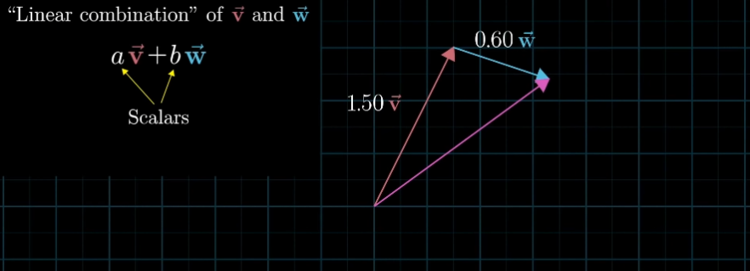

* Ranging of vectors freely can lead to each and every possible point in the 2-D plane. There are 2 cases where this possibility can change and those cases are where the two vectors line up on each other (points on a line in coordinate system) or both the vectors are zero vectors (both vectors would remain at origin).

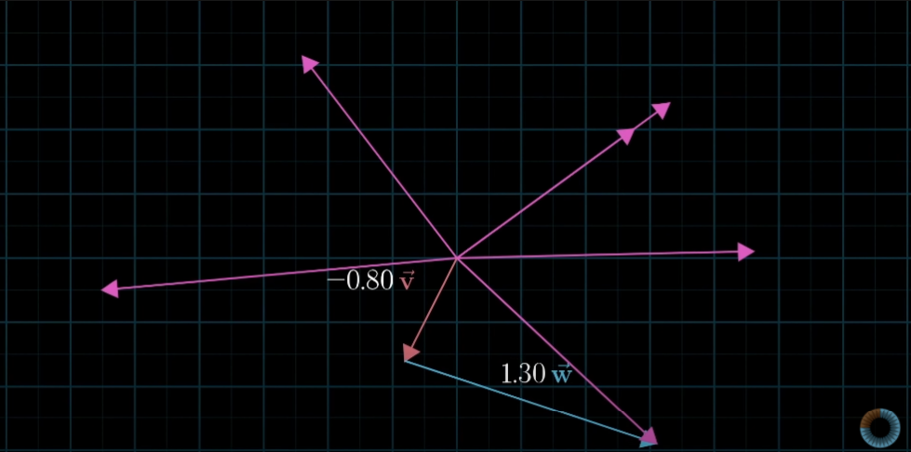

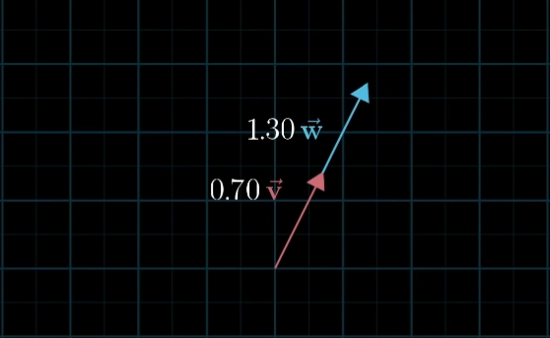

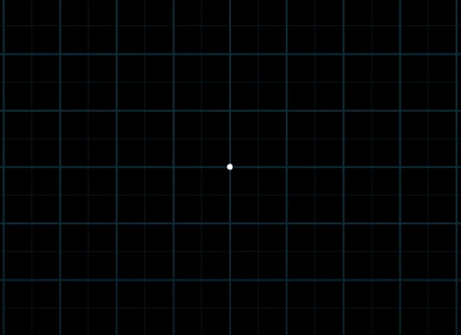

* Something similar can be done in 3-D space where there are some cases where access to all the points on 3-D space is not possible and points accessible lie on a flat sheet cutting in such a way that vector lie on them.

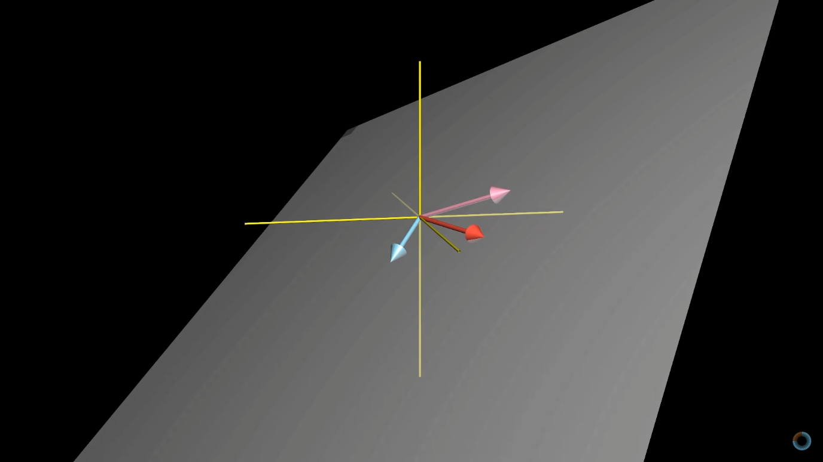

* When multiple vectors lie on similar span of flat sheet and one vector can be removed without changing span of flat sheet. In that case vectors are called linearly dependent.

When other dimensions are added by vectors and don’t lie on similar span, in that case they are called linearly independent.

* The basis of a vector is a set of linearly independent vectors that span the full space.

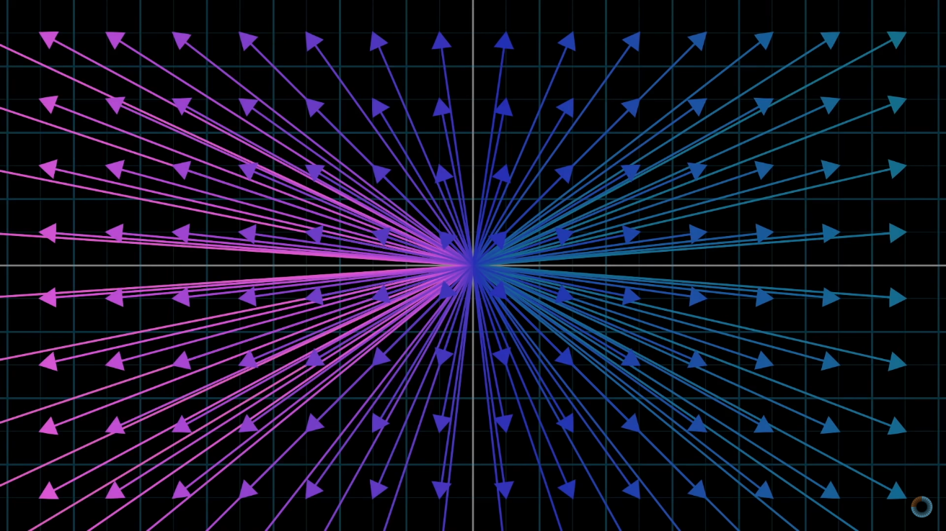

**LECTURE_3**

* In linear transformation, word “transformation” means “function”. It takes input and gives out some output.
* Now we use transformation word so that visualizing concept becomes easier for better understanding of concept.
* A transformation is linear if it has two properties: all lines must remain lines, without getting curved and the origin must remain unchanged or we can say fixed in place.

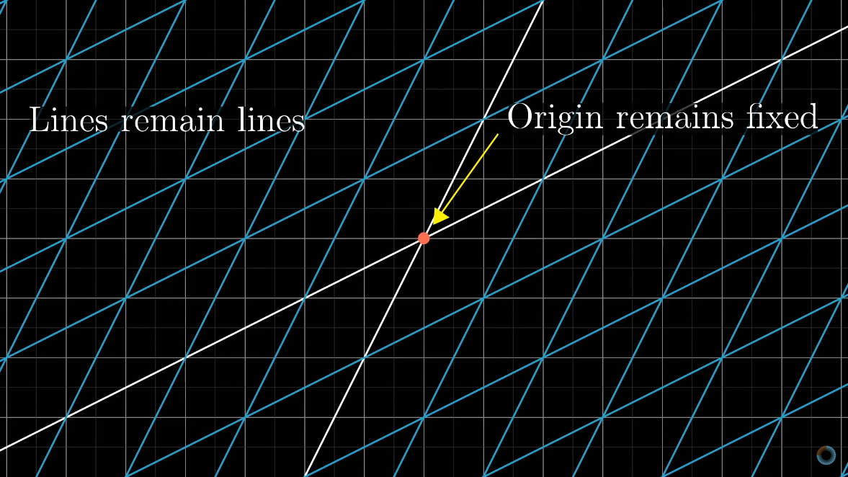

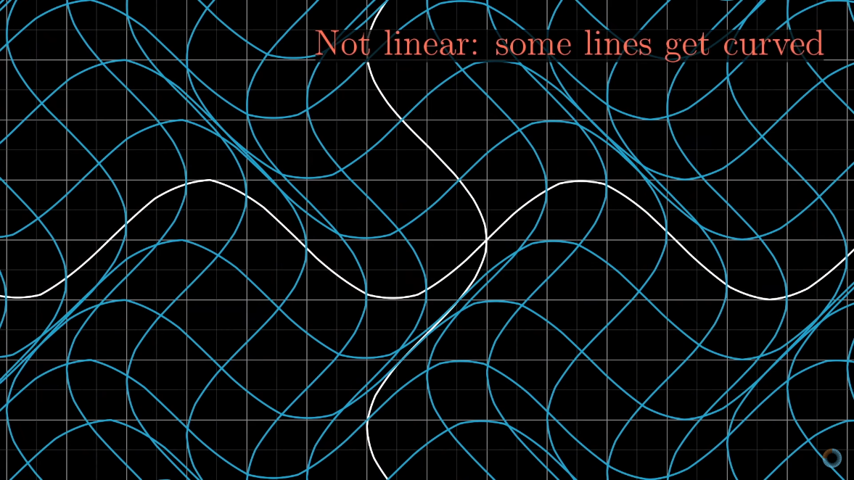

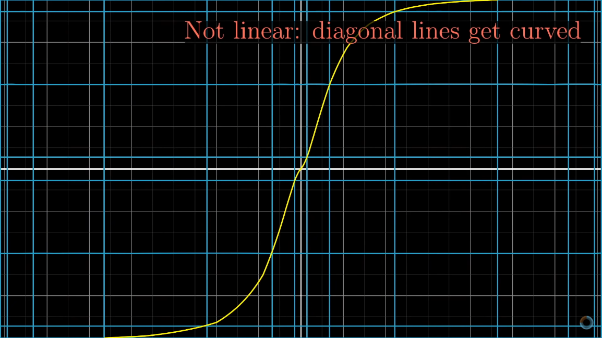

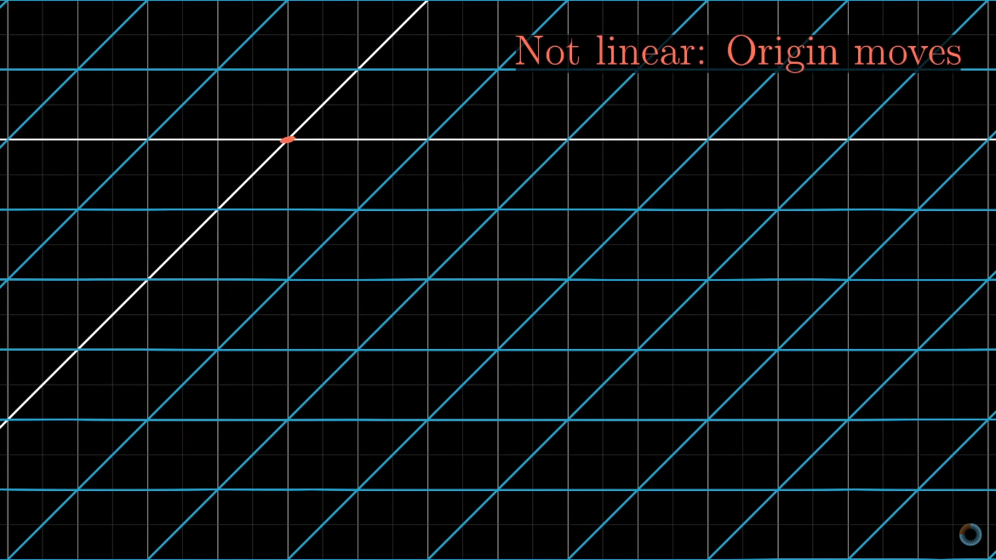

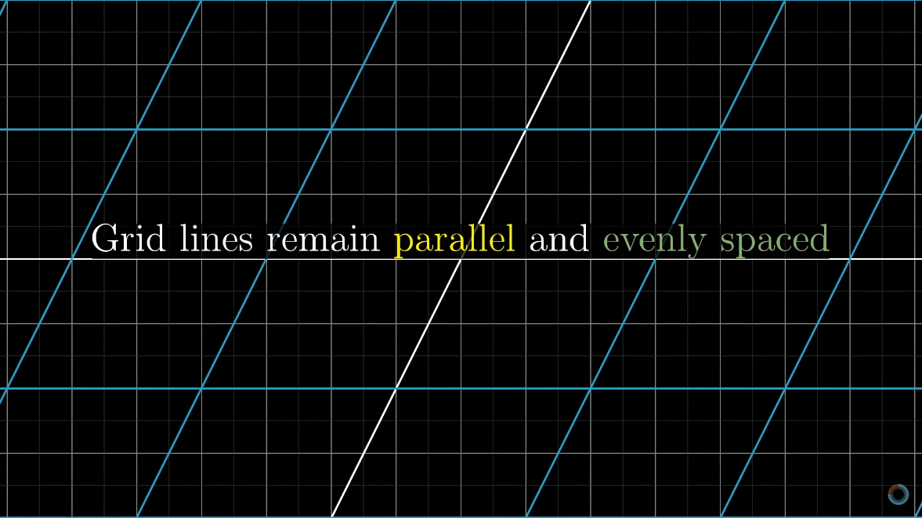

* Square matrix can be used to as a way to keep coordinates. In 2X2 matrix a column can represent a coordinate on 2-D plane and operations can be done on the matrix which can be visualized on 2-D plane itself.

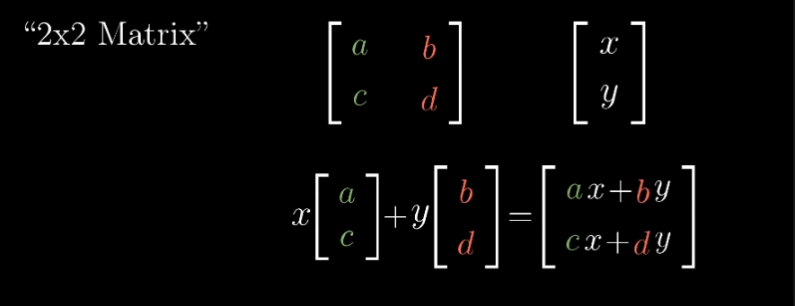

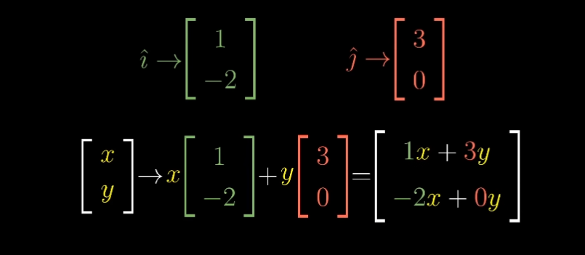

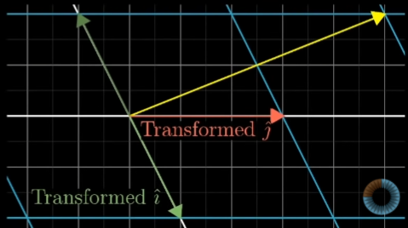

* Two linear transformation we can see here are firstly, we can move counter clockwise in 2-D space and other being called “shear” where i-hat remains fixed but j-hat moves to coordinate (1,1) without changing origin.

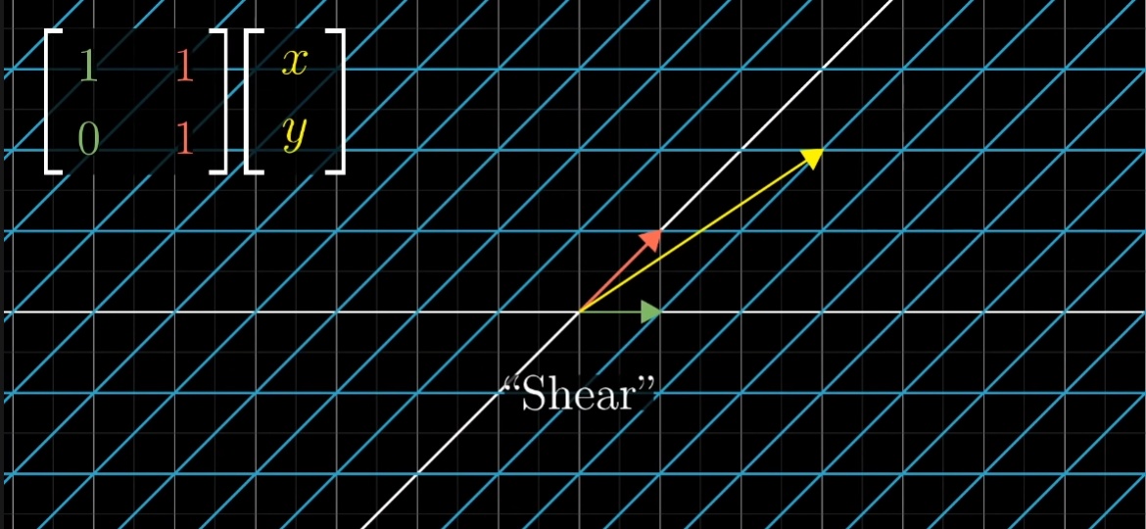

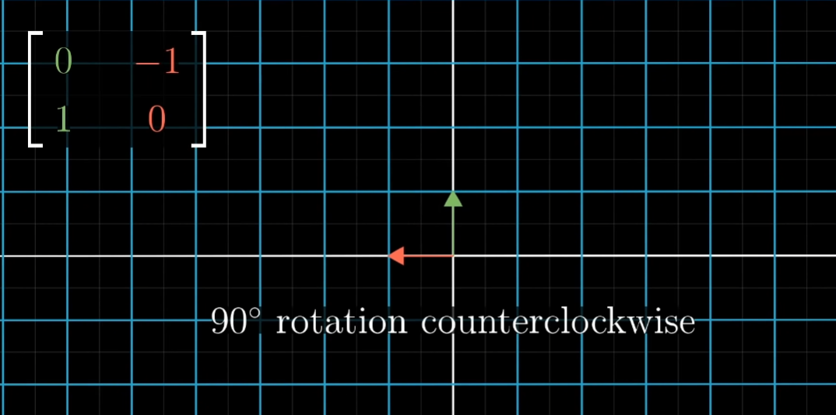

**LECTURE_4**

* If one or more linear transformations are applied in a particular manner it can give another linear transformation. One of them being called composition where rotation is done on vectors and then shear is applied.

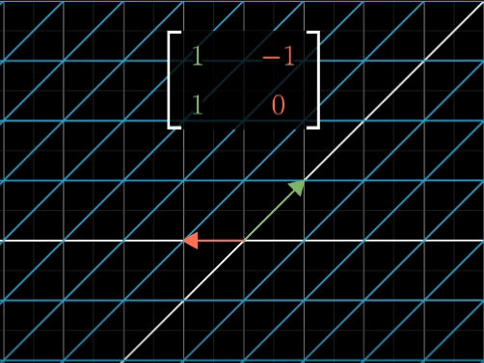

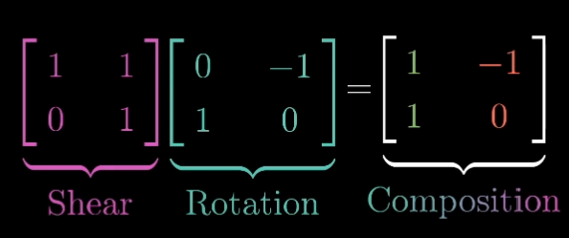

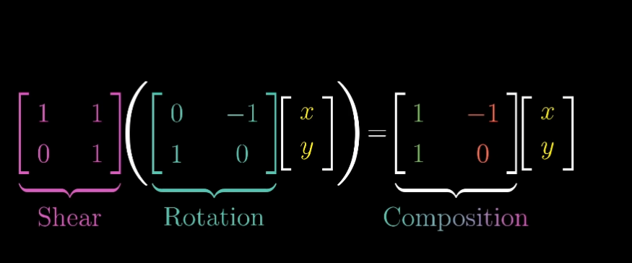

* It is important to remember that multiplying matrix is nothing but applying geometrical transformation in space in a particular way. Space differs depending on the type of the matrix.
* It is also important to remember that the matrix multiplication is read from right to left because of being in form of composite functions f(g(x)).
* Matrix multiplication can be understood in various ways. To understand one of the way look in the image.

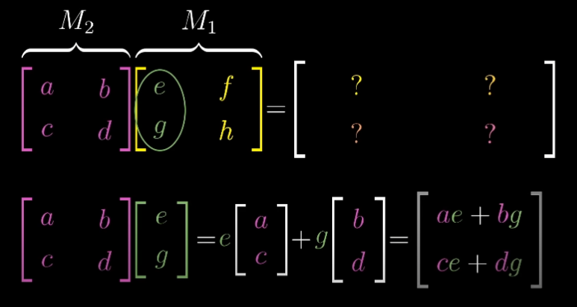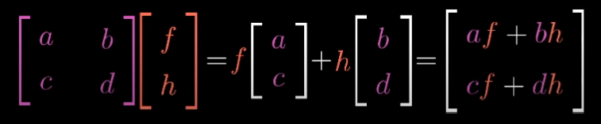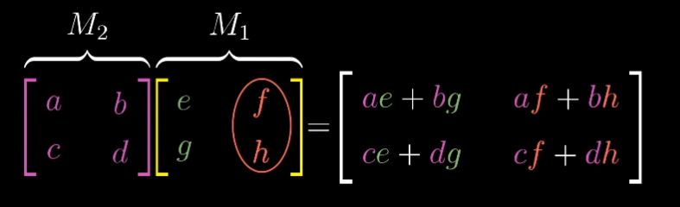

* Always remember that order of multiplication i.e., commutative property in matrix very much matters.

**LECTURE_5**

* Rules and understanding of matrix (in 3-D space) is pretty similar to one given in 2-D space. Matrix and 3-D space is much more about visualization then remembering.

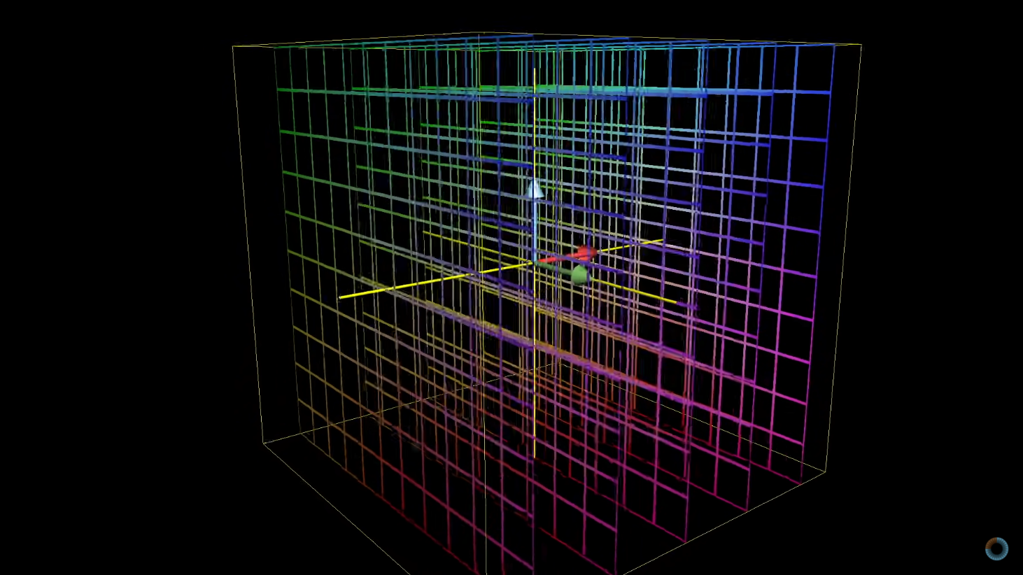

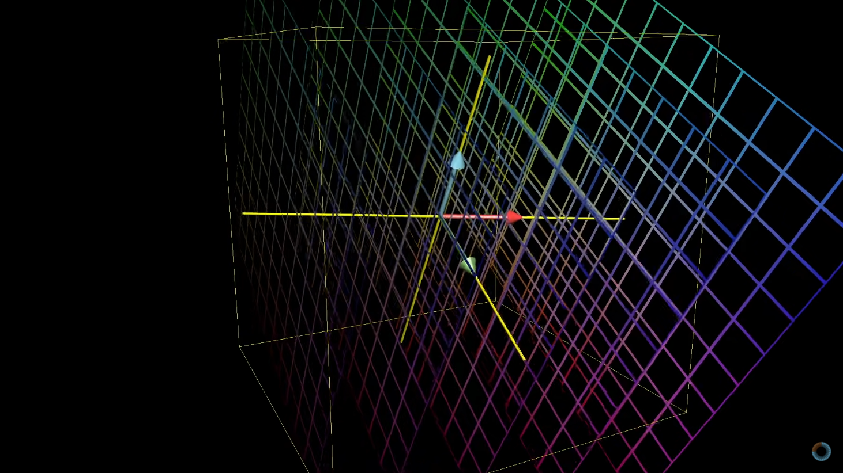

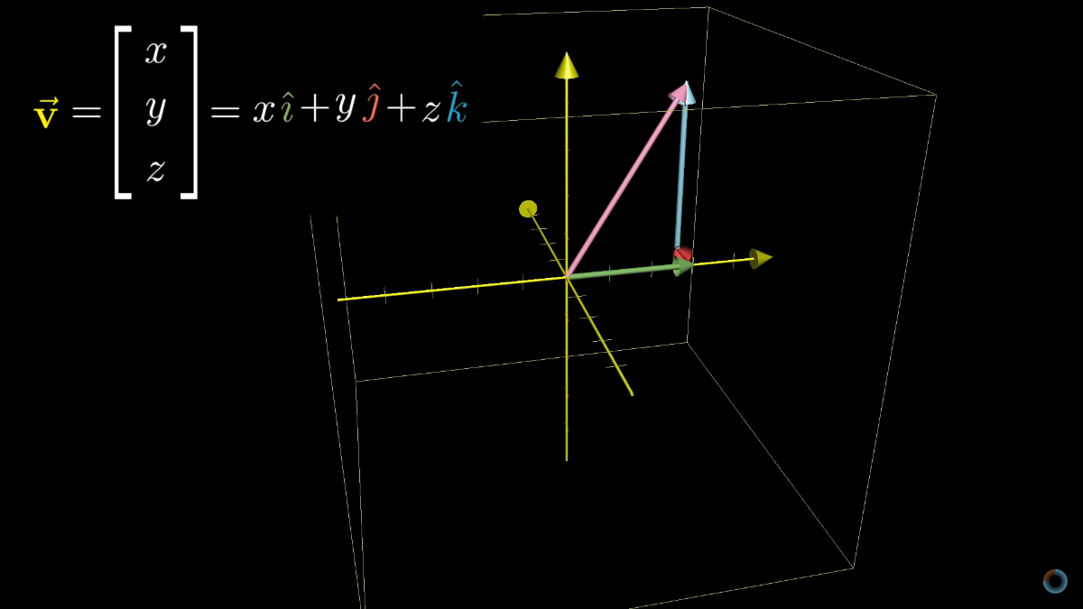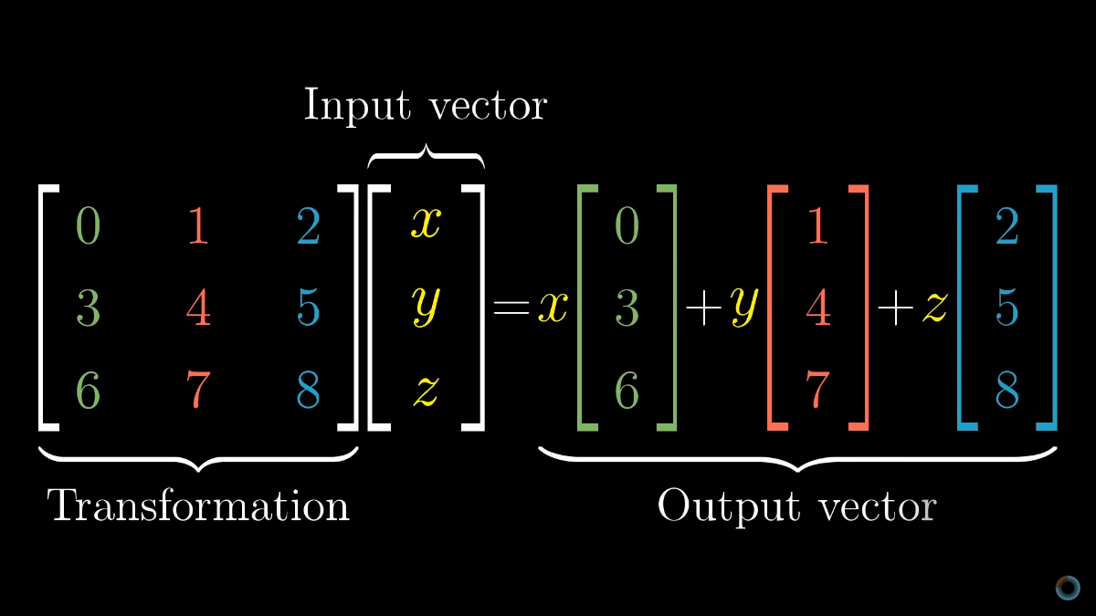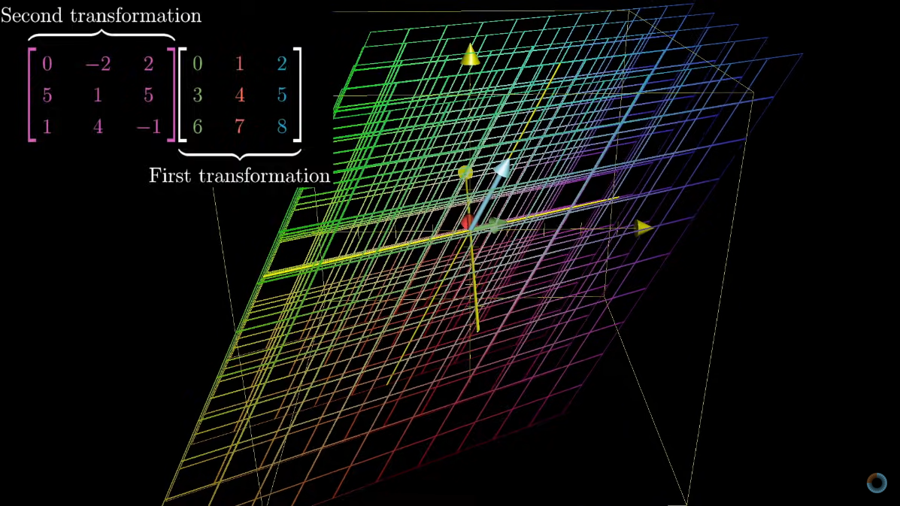

**LECTURE_6**

* The scaling factor by which a linear transformation changes any area is called the determinant of that matrix.

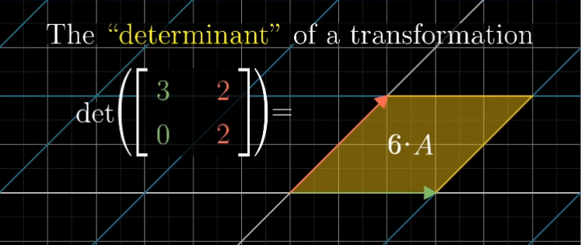

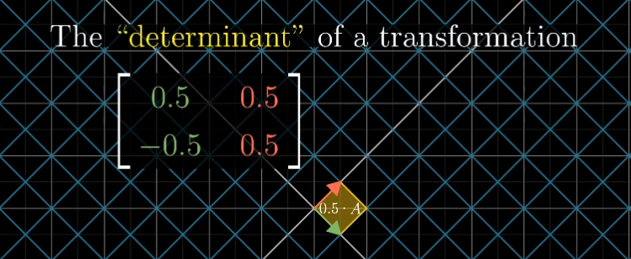

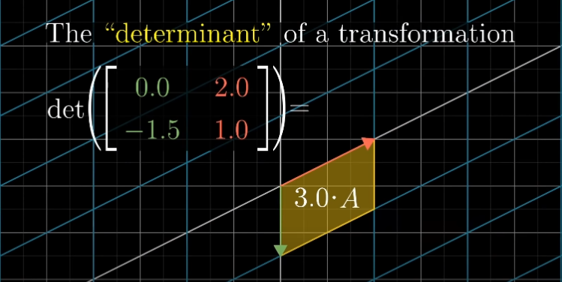

* Determinant of any matrix is zero whenever that transformation squishes the space into a straight line or even into a single point. Area of any region becomes zero.

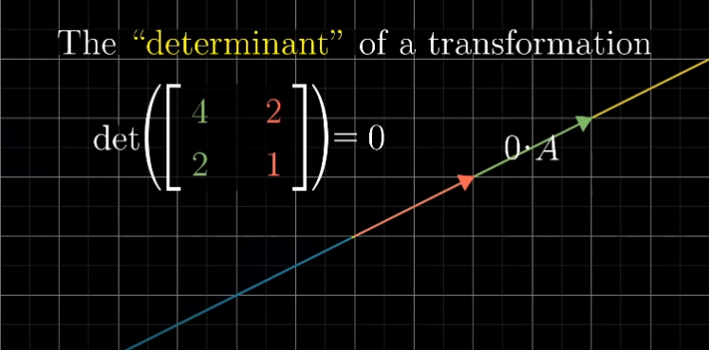

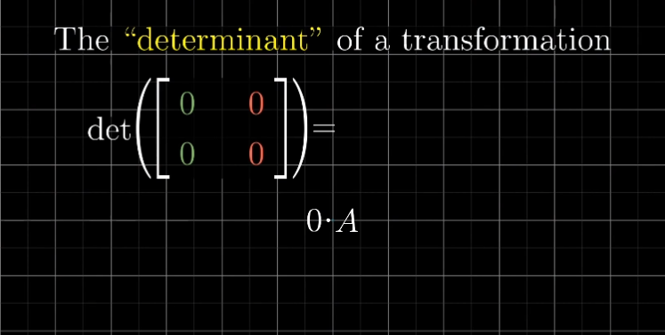

* Determinant can be a negative number also; negative number means the inversion of orientation of space.

Absolute value still tells the factor by which area is scaled.

Wrong Orientation but correct scaling of area

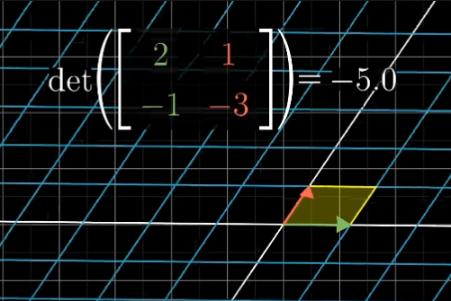

Correct orientation with correct scaling of area

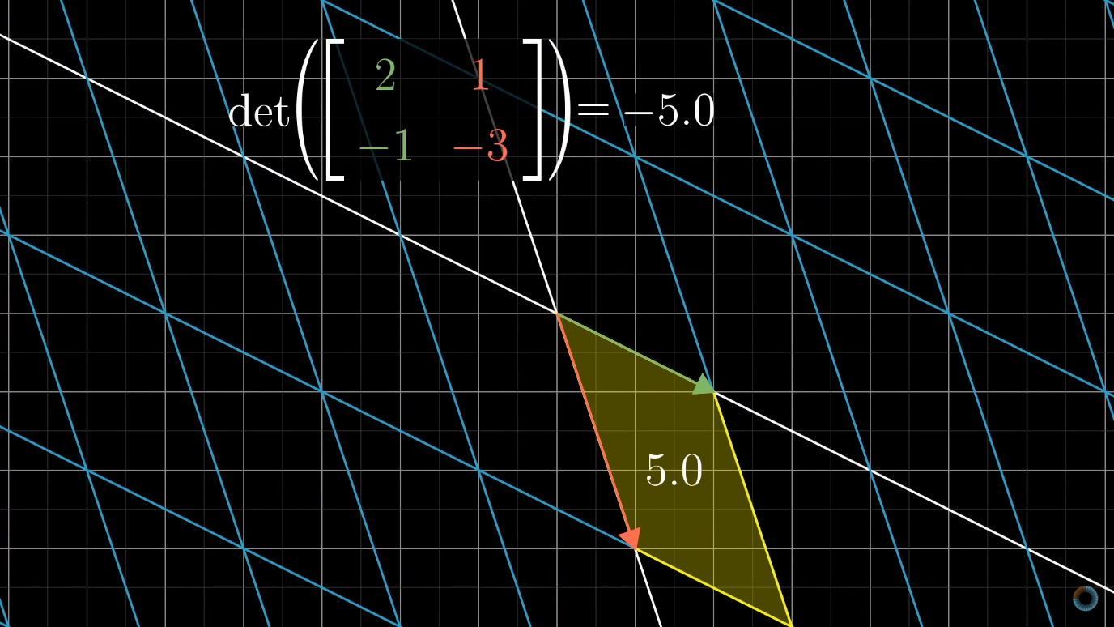

* The basic figure which helped us in understanding the 2-D space scaling is rectangle whereas in 3-D space the figure that help us in understanding scaling is cube. After transformation cube might look like a parallelepiped.

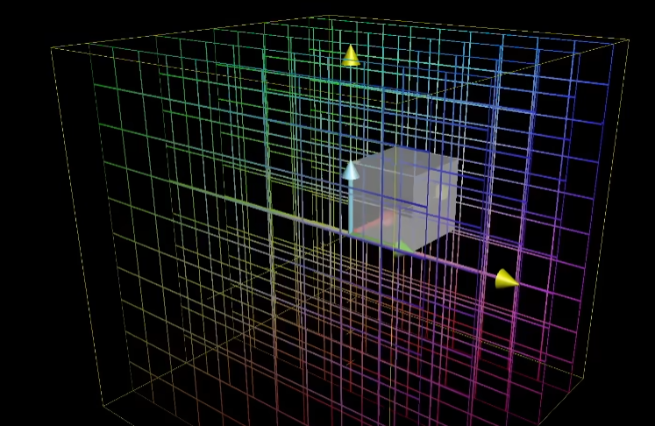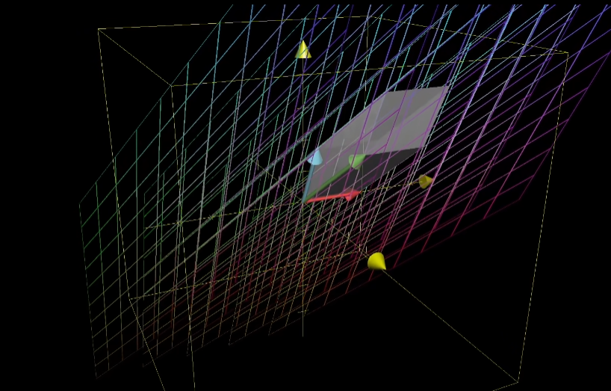

* Determinant of matrix gives the scaling factor by which any volume changes in 3-D space. A zero determinant in case of 3-D space is very similar to 2-D space, in 3-D space zero determinant follows whenever volume is zero i.e., a flat plane, a straight line or a point.

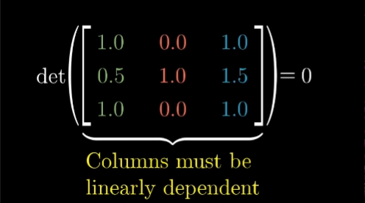

* Negative determinant of matrix gives inversion of orientation of space and in case of 3-D plane this can be proved using left hand rule (during inverted orientation) as right-hand rule will work for correct orientation only.

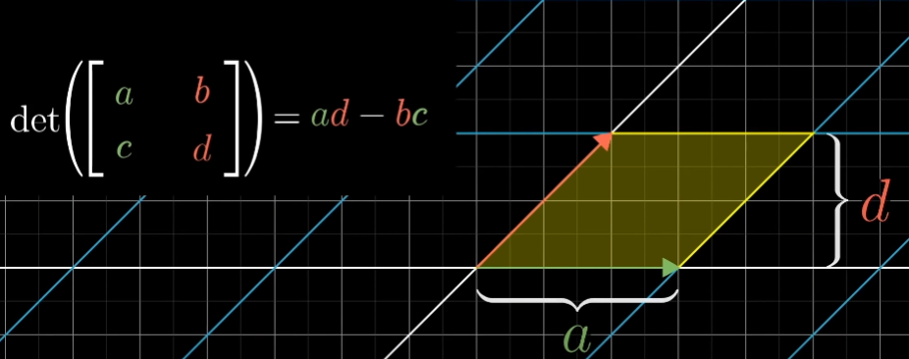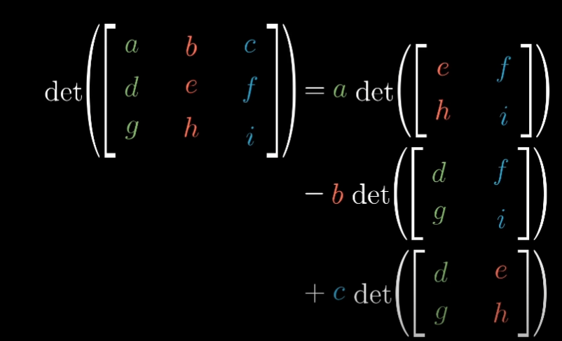

**LECTURE_7**

* Linear system of equations is an organized way of writing addition of different unknown variables to give some values. Using the given values unknown variables can be calculated. This linear system of equations resembles matrix and they can be arranged into some matrix to give out the same equations.

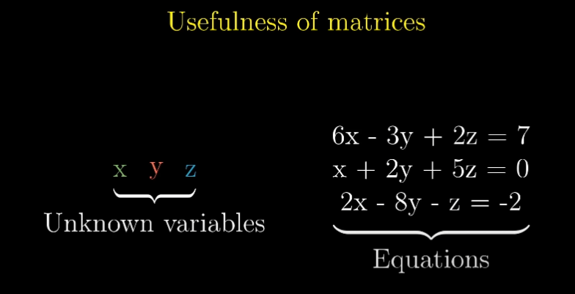

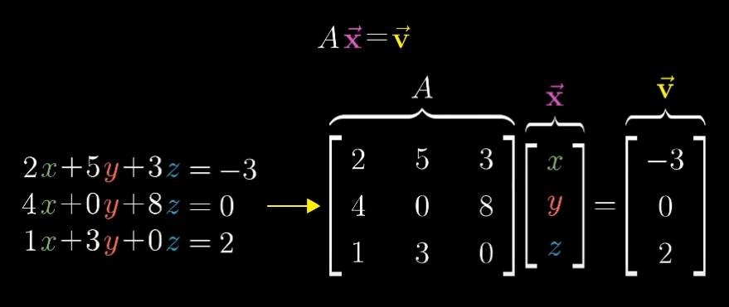

* The equation Ax = v helps us to understand the transformation done by matrix A on vector x so that after transformation vector x lies on vector v.
* Solution of Ax = v depends on transformation whether the transformation squishes everything to 1-D or it spans everything in 2-D. It is depend on determinant being zero or non-zero respectively.
* For det(A) not equal to ZERO there will always be one vector x that lies on vector v and to determine that vector x we can apply transformation in reverse. Ax = v. Inverse transformation gives a matrix called inverse matrix.
* Matrix multiplication with its inverse gives an Identity matrix and identity matrix does not do anything.

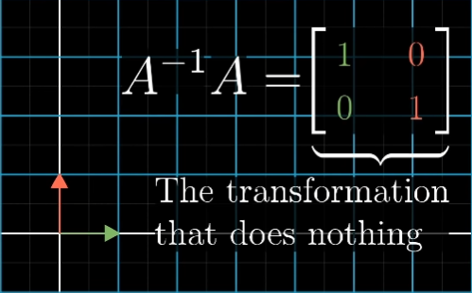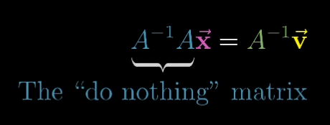

* Whenever number of equations are equal to number of unknown variables there is likely to be a unique solution.
* For det(A) not equal to zero there is A-1 will exist.
* Solution can still exist when det(A) = 0. As det(A) = 0 it means the vectors are flat plane, straight line or a just a point. It is difficult for a solution to exist on a line than to on a flat plane.
* So, to replace zero determinant term we have created a new terminology called rank and if output of transformation is a line(1-D), rank of a matrix is 1.

If all vectors land on some 2-D plane then transformation has rank 2 so on.

* RANK – Number of dimensions in the output of a transformation.
* Set of all possible outputs for matrix whether line, plane or complete space is called **column space** of the matrix.

In other words, column space is the span of the column of the matrix.

* The set of vectors that lands on the origin is called the **null space** or the **kernel** of matrix.

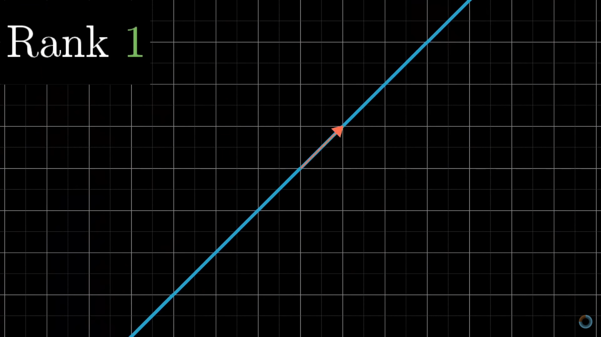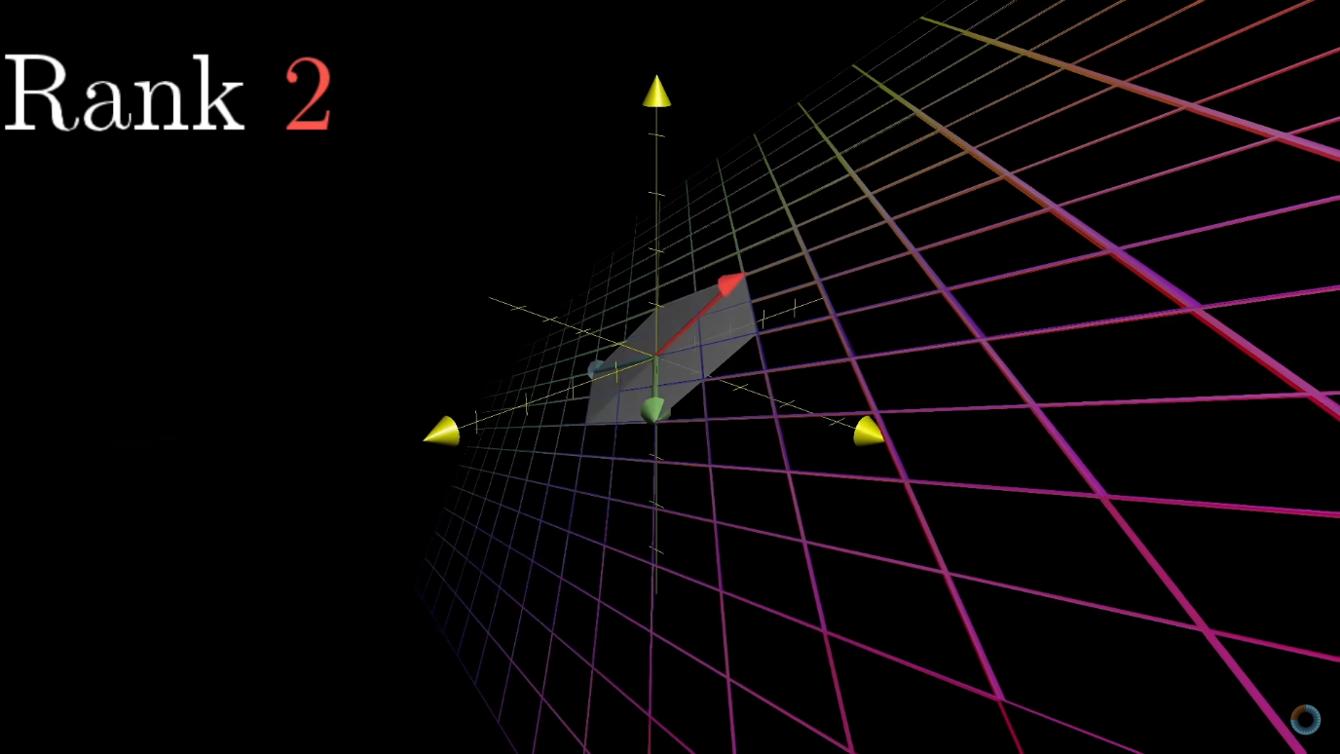

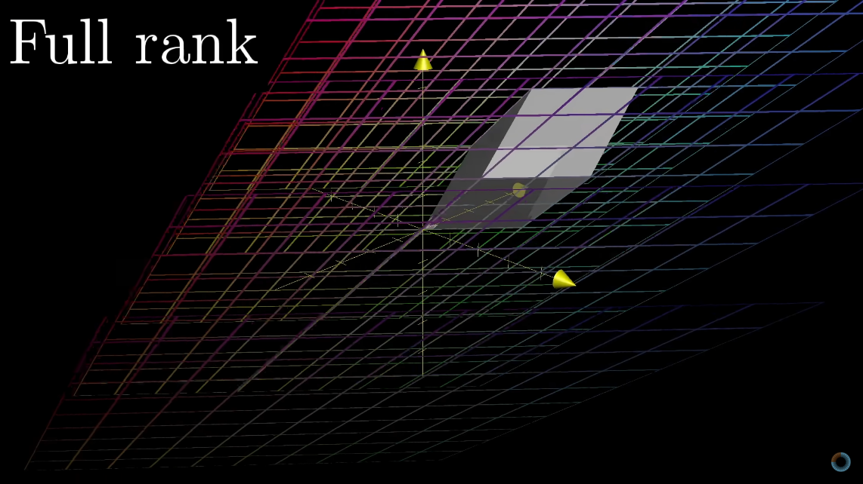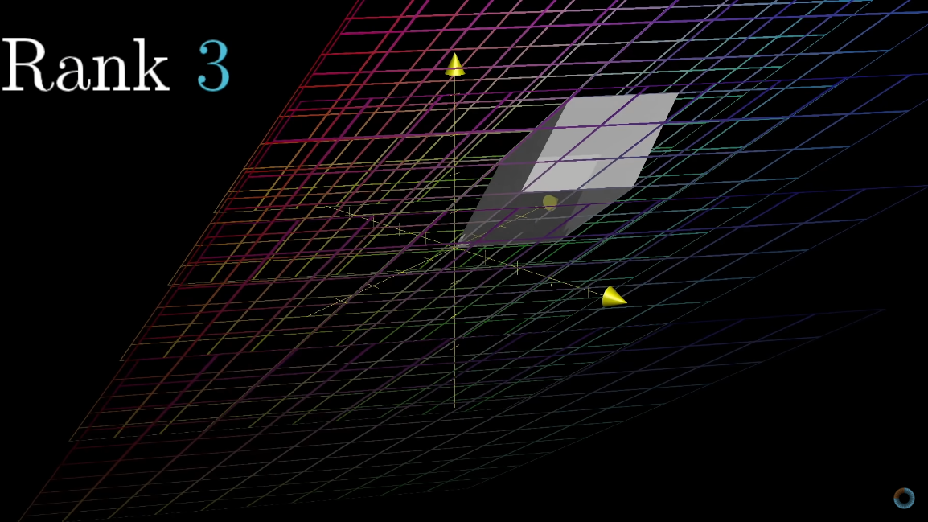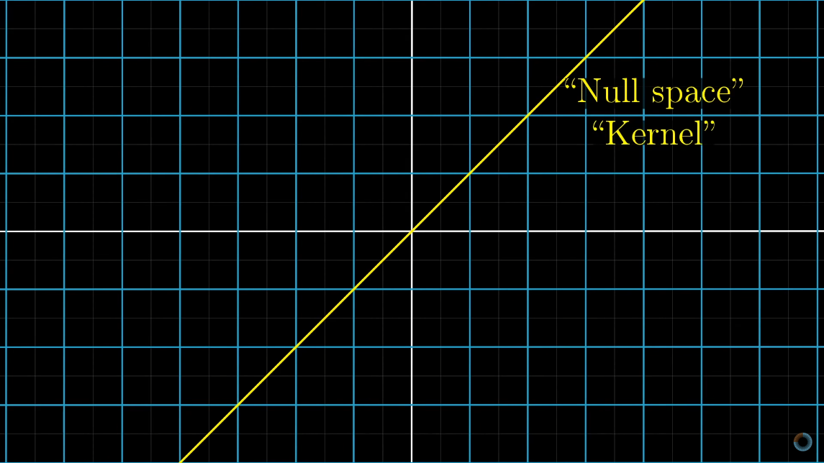

**LECTURE_8**

* For transformations in non-square matrices following must happen. So, if a matrix is of form **mxn** where m is the number of rows and n is the number of columns.  
  Here **n** represent the basis vector which tells us the dimension in which our input vector is whereas **m** indicates the landing spot for each of **n** basis vectors.

Example- below is transformation using 2x3 matrix.

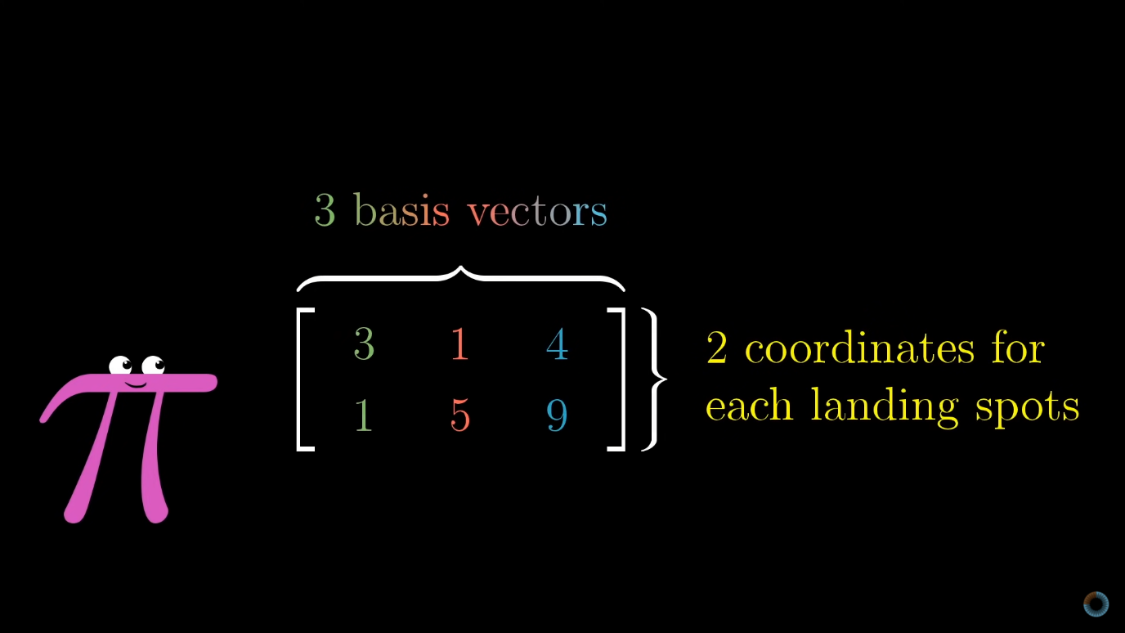 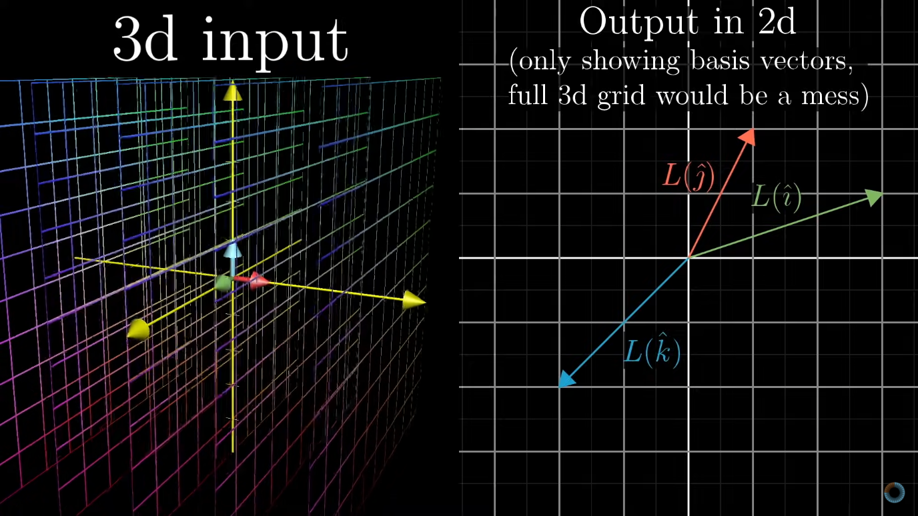

**LECTURE_9**

* Dot Product is nothing but multiplying each corresponding value of different matrix and adding them to get an answer.

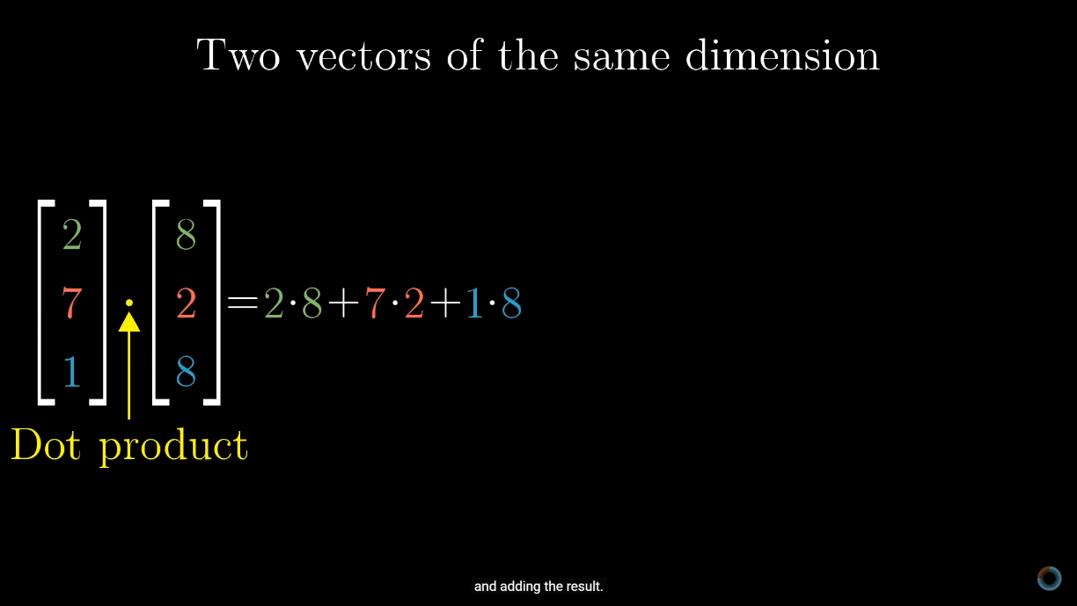

* In terms of transformation and space dot product is projection of a vector on another vector. There are some cases which will determine the sign of dot product. Both Order of projections will give the same result.
* Duality is shown by linear transformation and dot product.

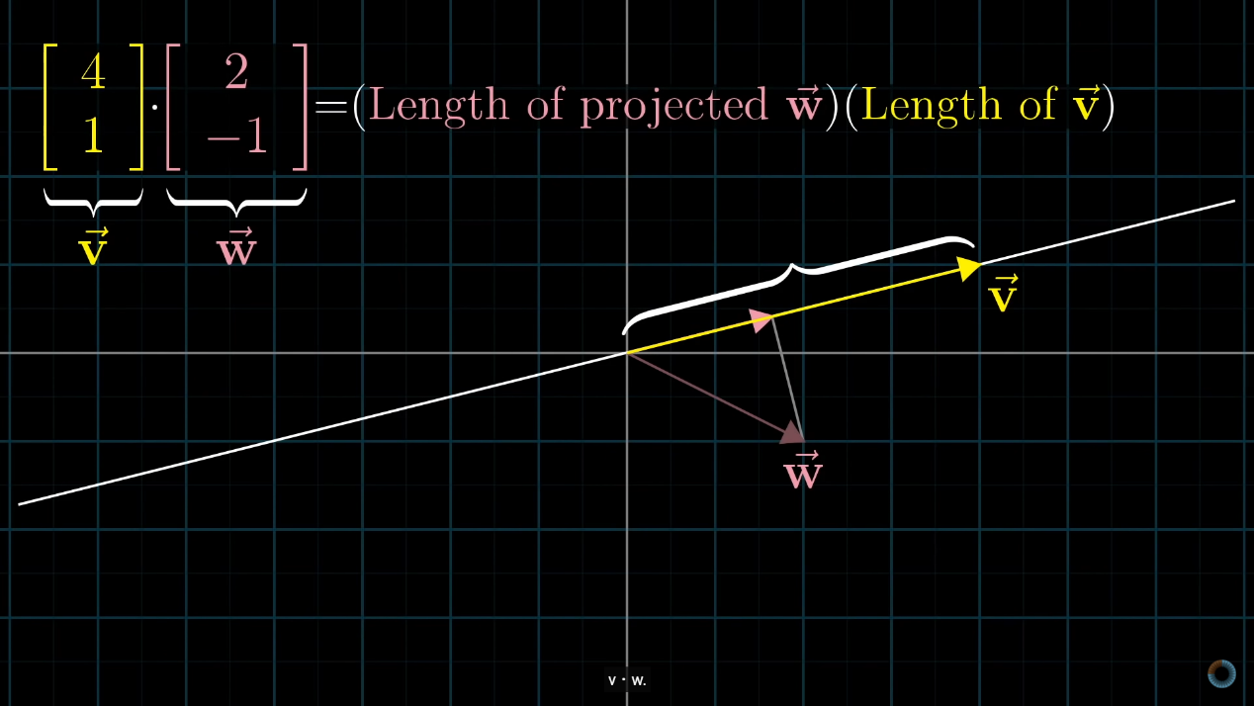

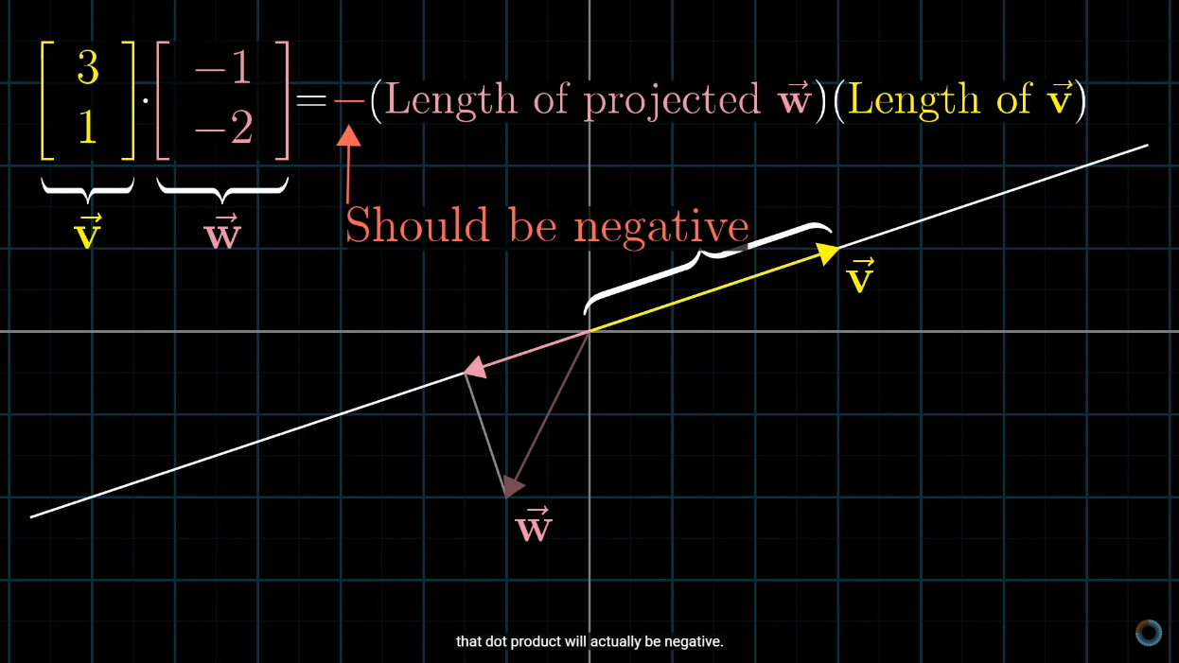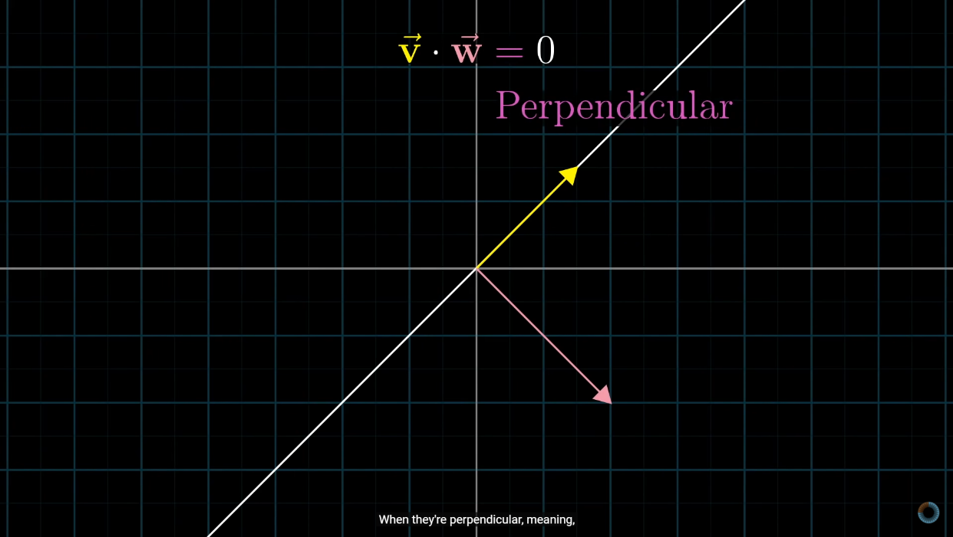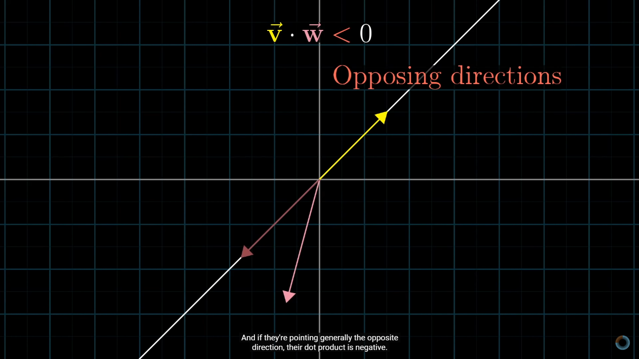

* Dot product help us to get the length main vector and can help give us the direction in which this vector is going to be.

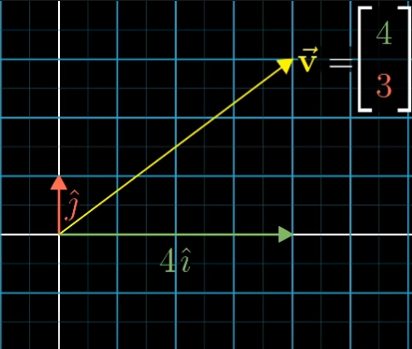

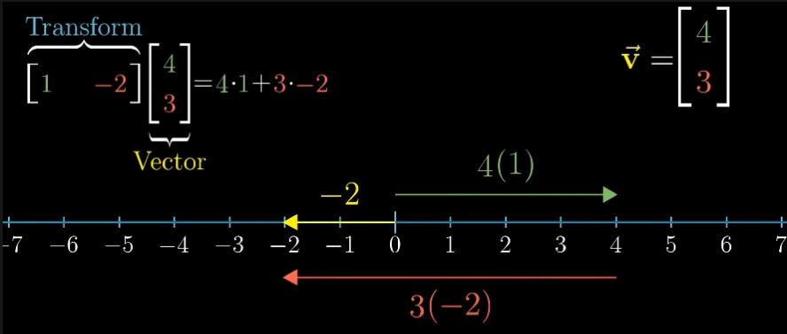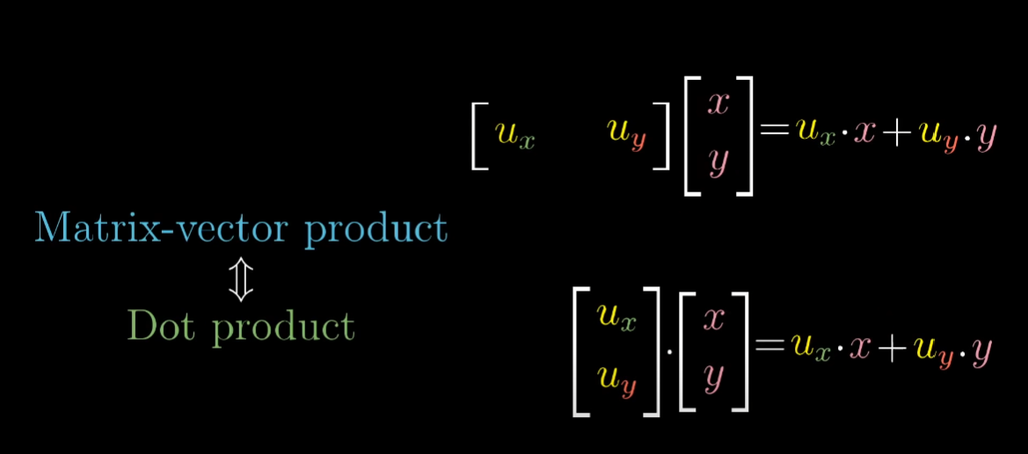

**LECTURE_10&11**

* Standard definition of cross product of 2 vectors is the area of parallelogram spanned out by 2 vectors in a space.

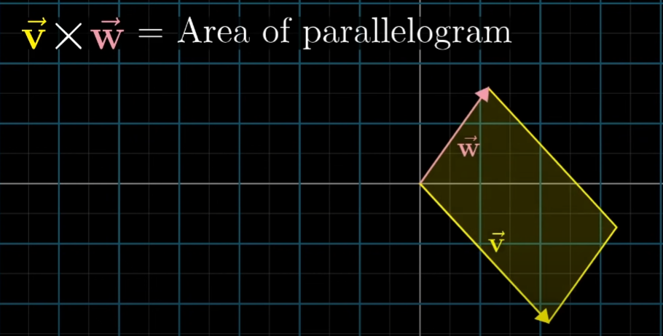

* Order in which 2 vectors are written matters because if we swap those two vectors then cross of those 2 vectors will become negative of each other. 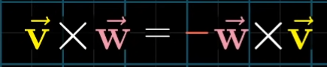
* Concept of cross product is very much similar to concept of calculating determinant. So to calculate cross product of two vector we need to write both the vectors in form of matrix and then find the determinant of that matrix.As determinant is nothing but the scaling factor by which area changes in a space.

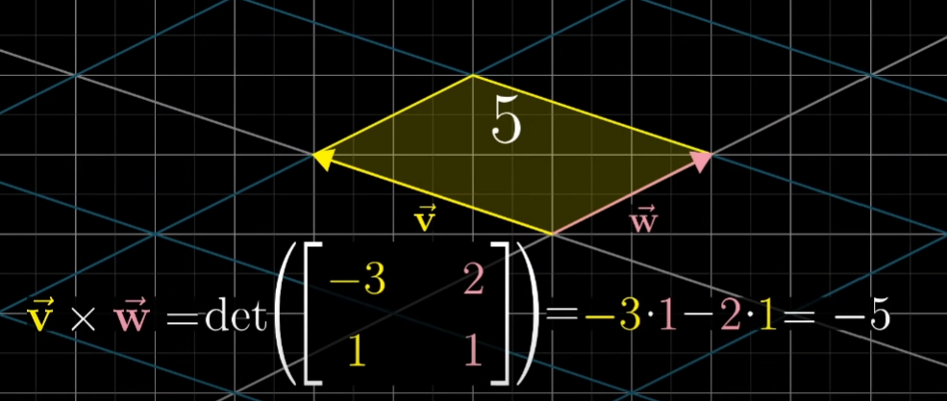

* Sign of cross product depends on the orientation of vectors. For positive value of cross product, the first vector should be on the right side whereas for negative value of cross product the first vector must be on the left side in space.

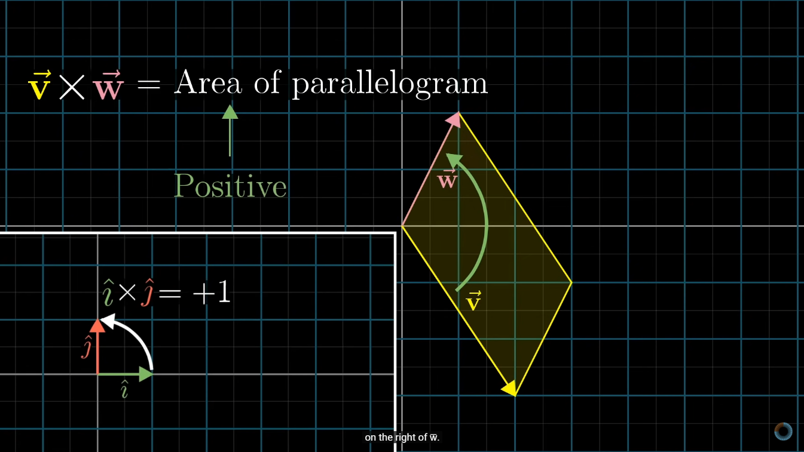

* One property of cross product being whenever the vectors are close to perpendicular in dimensional space the cross product or the area is bigger in comparison to that of non-perpendicular vectors.
* Another property of cross product is that scaling of a vector by an amount changes the cross product by multiplication of that scaling factor.

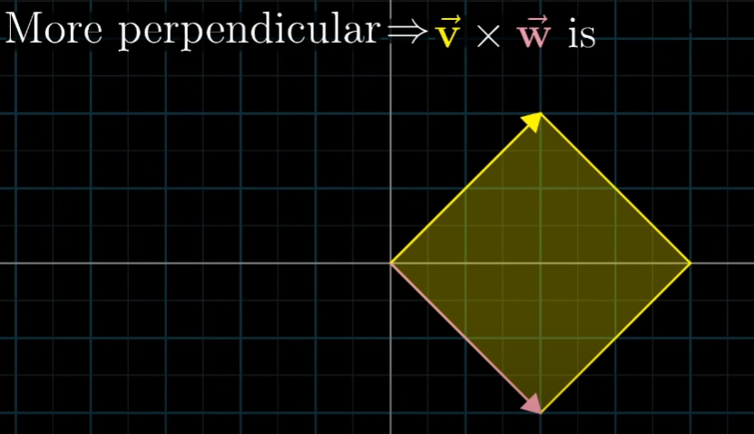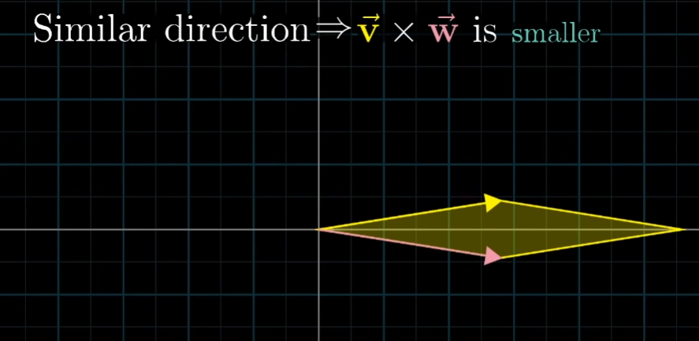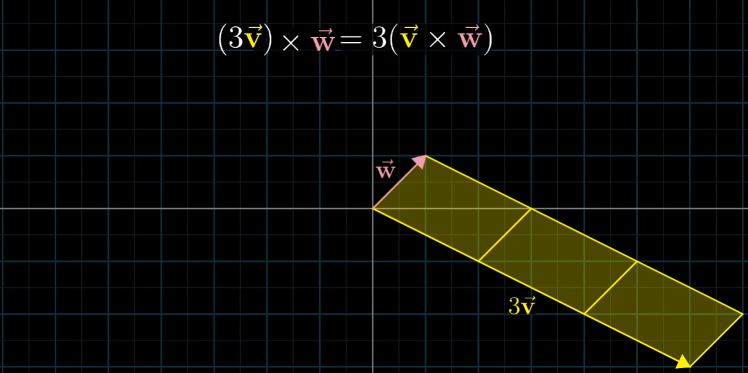

* Technically the true cross product is something that combines two different 3-D vectors to give a new 3-D vector. Area of the parallelogram given out by cross product is the length of the new 3-D vector. New vector is perpendicular to parallelogram too.

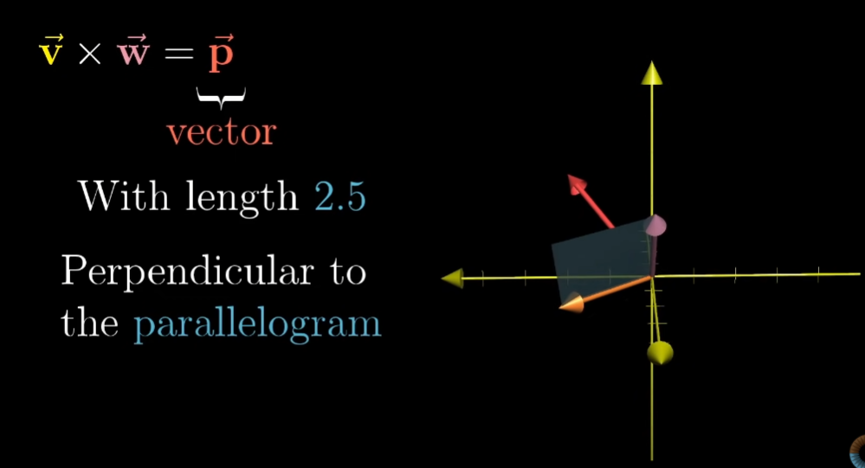

* Two vectors with same length are possible and to know the correct vector in correct direction with correct sign, we use right hand rule.

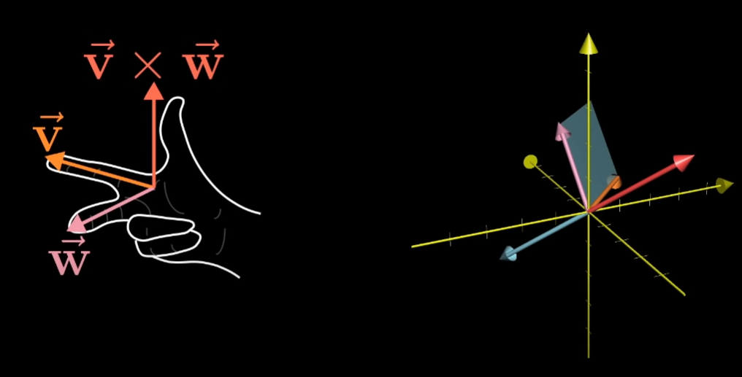

* Calculation in form of matrix

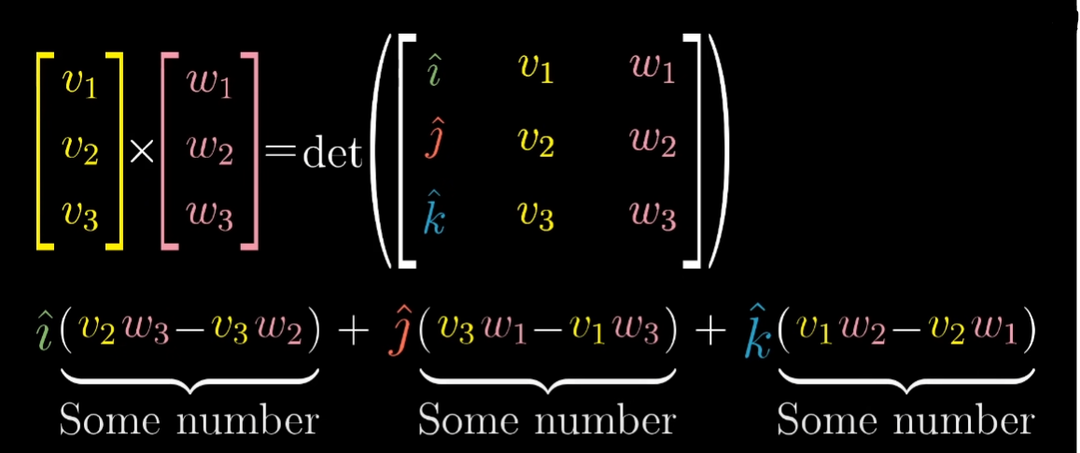

* Linear Transformation to the number line can be matched with some vector and that vector is called **DUAL VECTOR** of transformation**.** So, performing some transformation is similar as to take dot product with that vector.

**(IN DOT PRODUCT)**

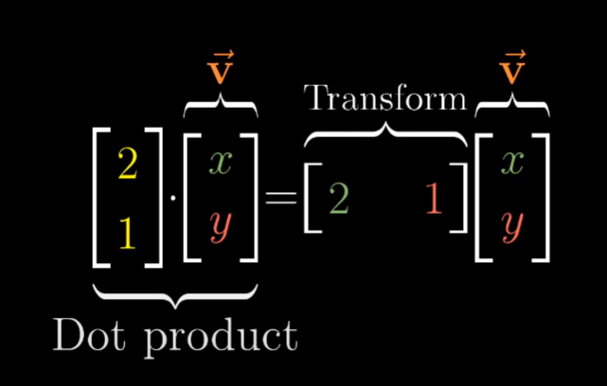

* For something similar process as of dot product what we will do is define a 3-D to 1-D (number line transformation) in terms of vector **v** and **w** and then associate the transformation with dual vector in 3-D space so that it can show that it is nothing but cross product.

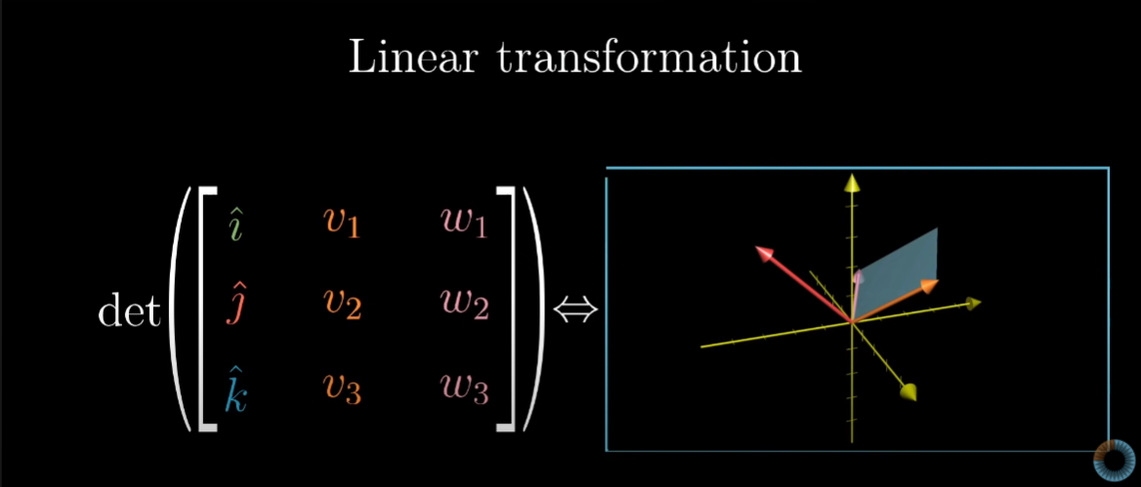

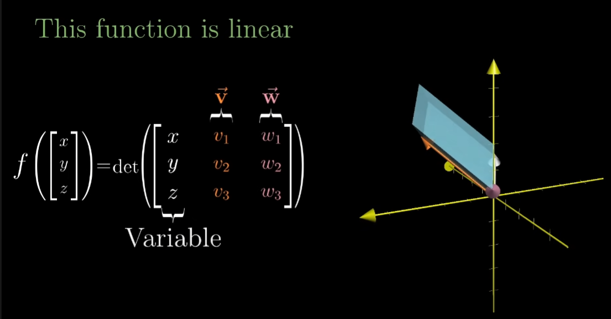

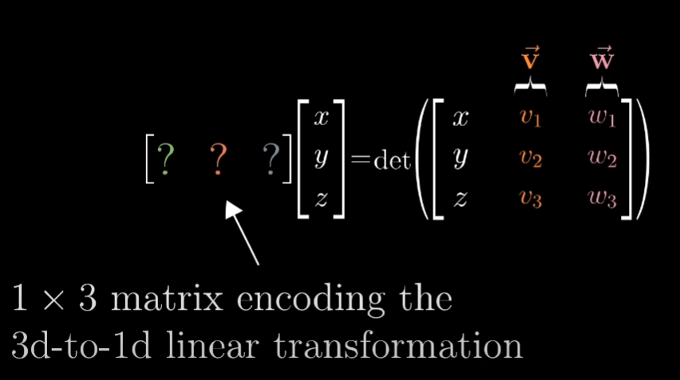

* From here duality comes into play, where conversion of one dimension to another can happen by turning matrix on its side (taking transpose) and interpret the entire transformation using dot product with a certain vector.

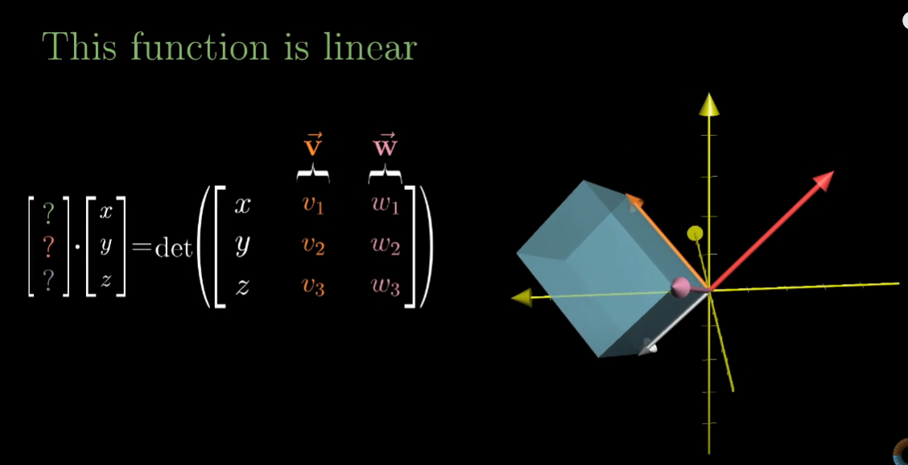

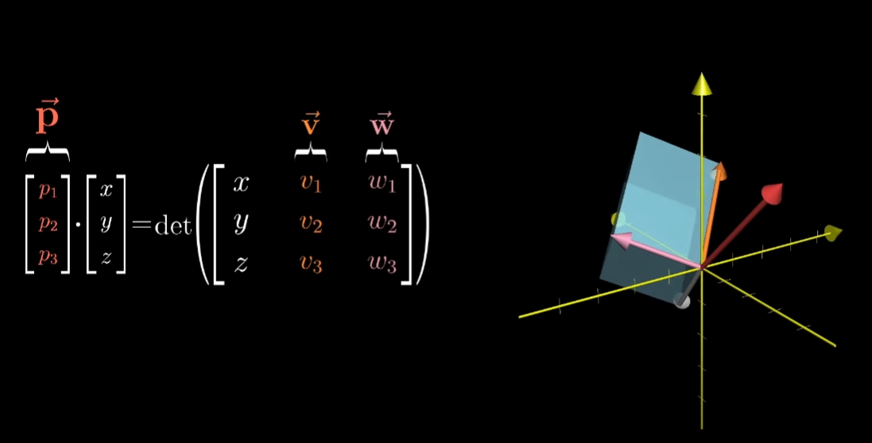

* I-hat, j-hat, k-hat are present just to simply tell that we have to compare them by some vector and same thing is proven using calculation shown in pictures below.

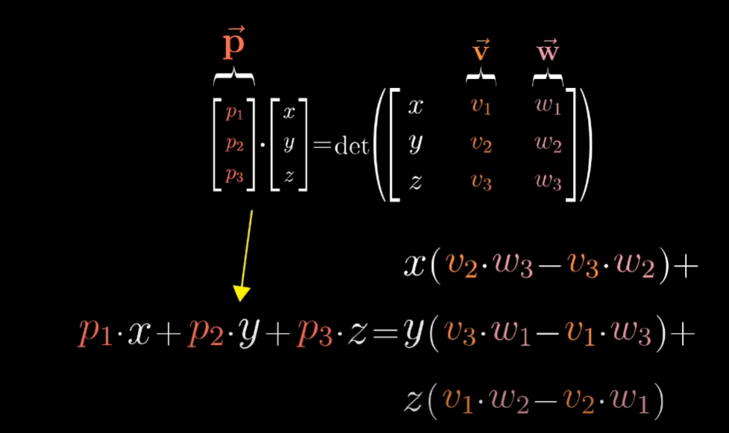

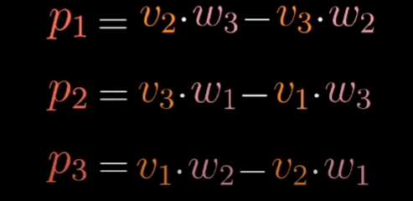

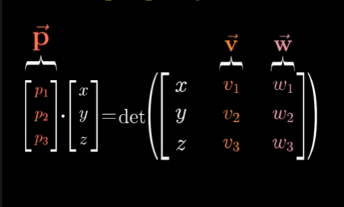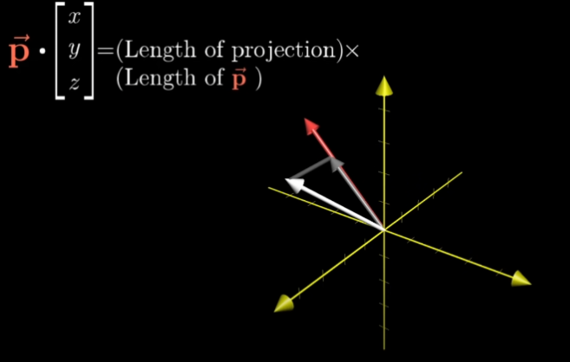

DUAL VECTOR (SILVER ARROW) 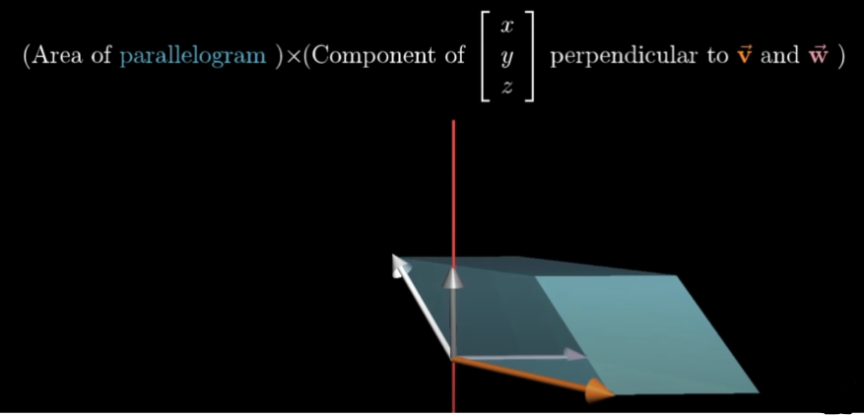

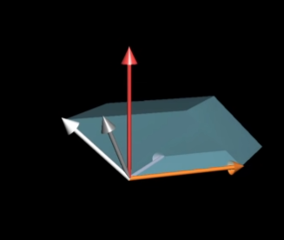

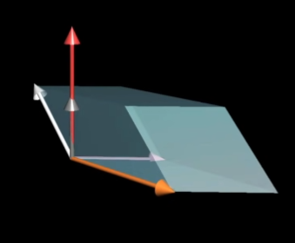

* From above pictures we can see that we found a vector p so that taking dot product of vector p with some vector **x, y, z** is the same thing as computing the determinant of 3x3 matrix whose columns are **x, y, z v** and **w**.

**QUIZ ANSWERS**

Q1. Why technical definition of basis makes sense?

(LECTURE 2)

Ans. Vector space here is nothing but 2-D or 3-D space in which vector can be represented and linearly independent vectors are nothing but the vectors that do not lie on each other and are different from each other.

Multiplication of each linearly independent vector by a scalar and Addition of each of those linearly independent vectors can span the full space (vector space i.e., 2-D,3-D so on).

**i-unit** vector and **j unit** vector are basis vector of x-y coordinate system because they are linearly independent as **i** have values at x axis(i,0) and have no values for y axis and in j unit vector j has values in y axis (0, j) but no values at x axis so they will not overlap each other (Linear independent) so that is why i and j can span over full space that is coordinate system here.

Now we know that basis is a set of linearly independent vectors that covers or span the full space and that is why this definition of basis makes sense.

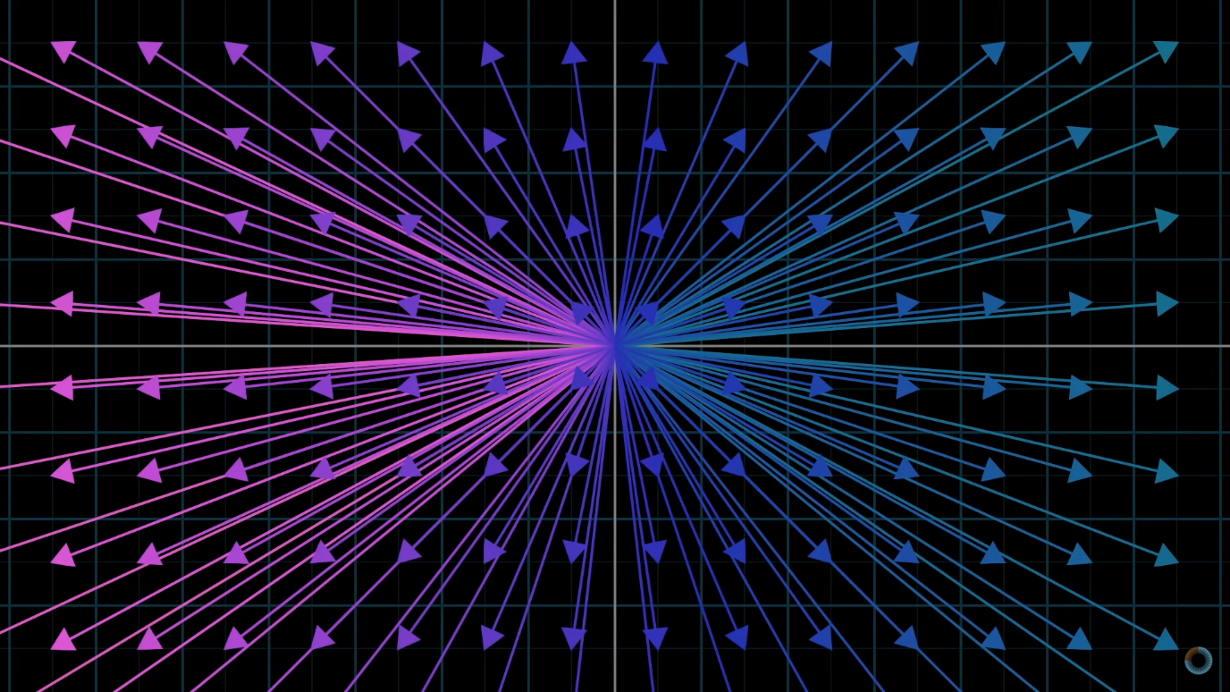

Q2. Explain in one sentence rather than doing calculation det(M1M2) = det(M1)det(M2).

(LECTURE 6)

Ans. It is well known that determinant is scalar as it represents scaling factor of an area of transformation in space.

On the left side, the Matrix multiplication done is nothing but transformation in space happening from right matrix(M2) to left matrix(M1) and then calculating the scaling factor(determinant) of an area in space whereas on right side, the scaling factor of an area(determinant) by individual matrix are calculated and then simply multiplied. Because of determinant being scalar the answer will be same on both sides.

SUBMITTED BY: -

VIKHYAT BANSAL[CB.EN.U4AIE21076]

***THANK YOU***